# **Mount DBA PC(Windows8)**

## ***1. Import OVA file (DBA PC(Win8).ova)***

- File - Import Appliance - Select CentOS7 Image

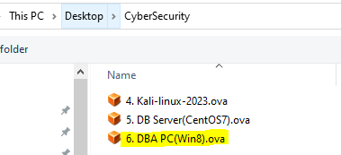

- After importing, you can see DBA PC in the VM list

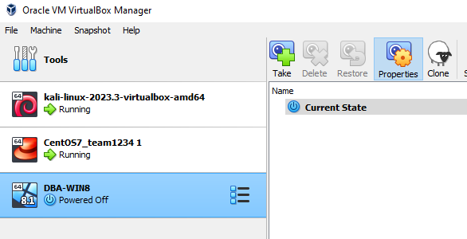

* DBA-WIN8 – Settings – Network – Select Adapter1 and tick “Enable Network Adapter”

***2. Check network***

- Run DBA PC



- Open Terminal:

Press Windows Key + S

cmd

Run as Administrator

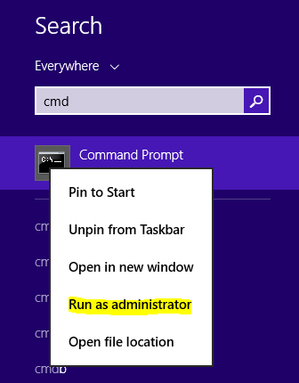

- In UAC warning window, Click 'Yes''

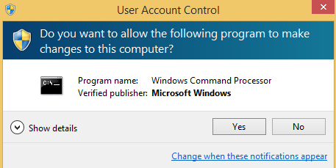

- Check IP

DBA PC> ipconfig

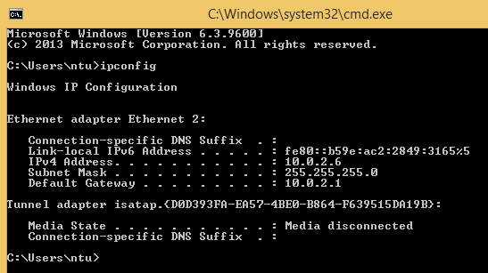

* IP is 10.0.2.6

- Check Internet connection

DBA PC> ping google.com

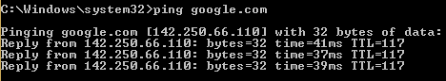

- Check Listening Port

DBA PC> netstat -anb

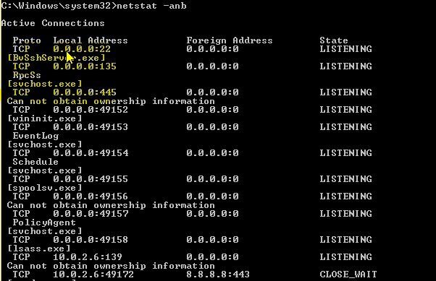

* 22, 135 and 445 port should be open to test

***3. Check DB server connection***

- Run HeidiSQL

1. double click

2. click <skip>

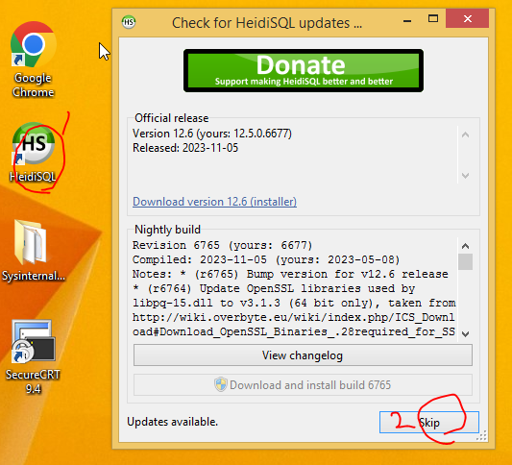

- Connect DB server (10.0.2.5)

Click <open>

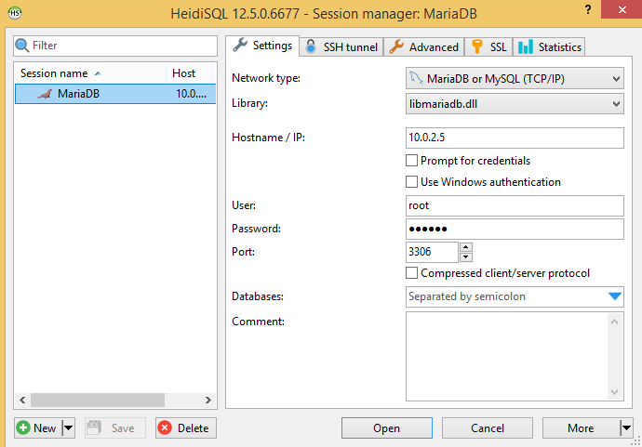

- If it is displayed, everything is ready.

